SharePoint Basic

* Default Permission

More reading: <https://support.office.com/en-us/article/Understanding-permission-levels-87ecbb0e-6550-491a-8826-c075e4859848>

* Master page + css

More reading: <https://support.office.com/en-us/article/Introduction-to-SharePoint-master-pages-dc9c4388-8dce-41b8-abb8-eeda2801b1a7>

* Webparts

More reading: <https://support.office.com/en-us/article/Introduction-to-customizing-pages-by-using-Web-Parts-cb196602-7b5f-4f98-9c8f-53ab96a74565>

* Custom aspx pages

Possible Solutions in which we can integrate Custom Aspx Pages into Share Point Site:

1. SharePoint designer approach: This approach is better when we work with few aspx pages and less functionality.

(not used by us)

1. Web Parts approach: This can be used in combination with SharePoint designer. But once again, developing many web parts is not  
   feasible solution and sometimes leads to performance issues.

(This is what Haworth SharePoint uses)

1. _Layouts folder approach: This is best and simple method of all. This method deploys the web application pages under the _layouts folder of Share Point Site and the pages can be accessed from any Share Point Site.

(This is what we use in KispSharePoint)

More reading: <https://msdn.microsoft.com/en-us/library/ff648535.aspx>

SnapTracker SharePoint Solution

* SnapTracker -> Single sign on -> SharePoint

(Kisp SharePointWeb -> Layouts -> Kisp.SharePoint.Authentication folder)

* SnapTracker Service forms

(Kisp SharePointWeb -> Layouts -> KispServiceForms folder)

* Web services for SnapTracker to call (turn Resource Area On/Off, set user permissions)

(Kisp SharePointWebService -> SharePointService.cs)

* WebParts (ManufacturerList & ManufacturerPageViewer)

(Kisp SharePointWeb)

Mosaic SharePoint Solution

* Mosaic Webparts (navigation, product, welcome page, contacts, gallery etc.. everything)

(Custom web part that act like a page; look into MosaicSharePointSolution)

SharePoint 2010 Summary

* .net 3.5
* SharePointWeb + SharePointWebService
* Custom Permissions (see file permission.xlsx)
* Util 2.0 (list all web application + run script on them)

SharePoint 2013 Summary

* .net 4.5
* SharePointWeb + SharePointWebService + MosaicSharePoint
* Custom Permission (same as above)
* Util 4.5 (list all site collection + run script on them)

Other

* Migrate 2007 -> 2010 -> 2013 (soon -> 2016?)

Steps refer to file “2013 Setup Haworth related docs/Haworth Sharepoint Upgrade 2007-2013”

**Create a build**

* Open Visual Studio, set build mode release
* Build > Deploy Solution
* Right click on Project and Open File In Explorer
* Go into /bin/Release and find the wsp file

*due to some migration issue in production we cannot deploy the wsp file directly*

* Open the wsp with winzip / winrar and extract everything into folder “Build xx.xx.xx.xx”
* Put the file in the following structure(look at previous builds for example)

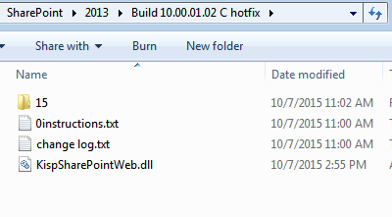

Inside 15/Template folder (this should be the same as your local 15 folder structure):

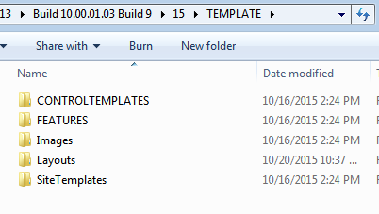

* Place the folder “Build xx.xx.xx.xx” into ftp SharePoint folder